**Renaming Liveries for Upload to SRL Google Drive**

If you want to have a custom livery ready to be used for the season, upload it after the above stated time with the correct naming convention for the folder! The naming convention will be as follows:

**SRL_[3 letter moniker of driver]_[car used]_[livery name]**

As an example, my livery from last season would be **SRL_HUB_991-II_Houkusai**

1. Open your file browser and navigate to:
   1. “Documents\Assetto Corsa Competizione\Customs\Cars”
2. Rename your Car .json file to match the livery naming scheme as shown below.
3. 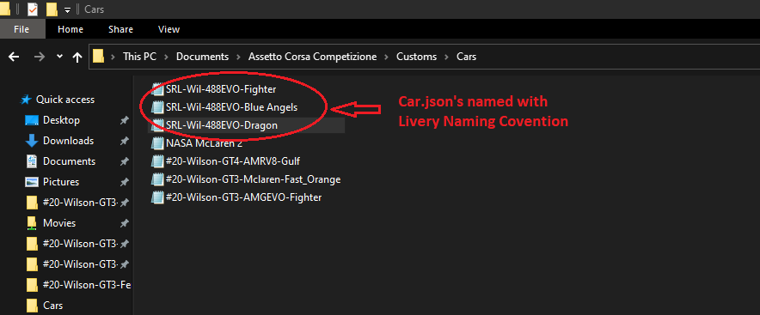
4. Open car .json file and rename the linked forder with naming scheme as shown in the following picture.
5. 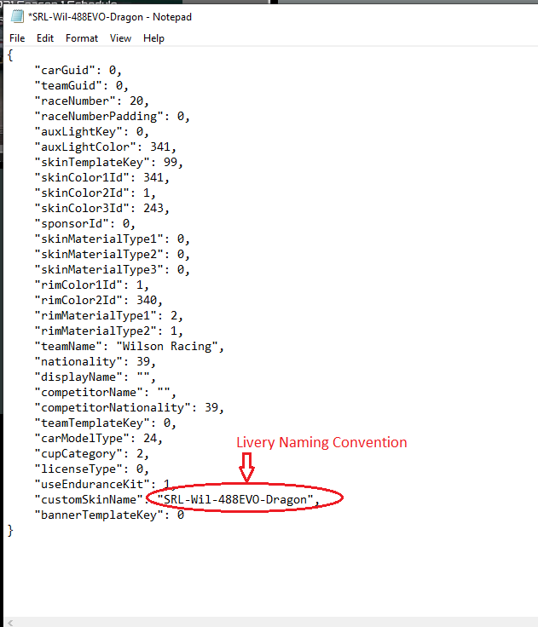
6. Using the file browser, navigate gat to “Documents\Assetto Corsa Competizione\Customs\Liveries”
7. Rename folders to match naming scheme.

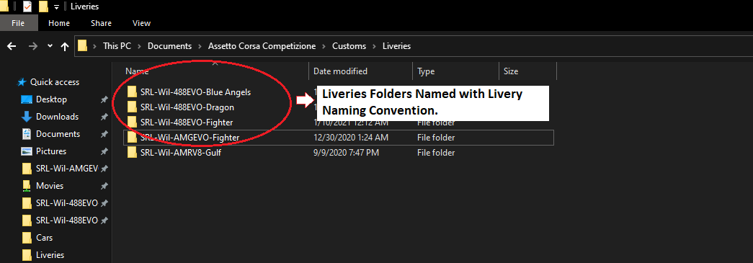

1. Now upload your car livery folders using the upload tool found at :